****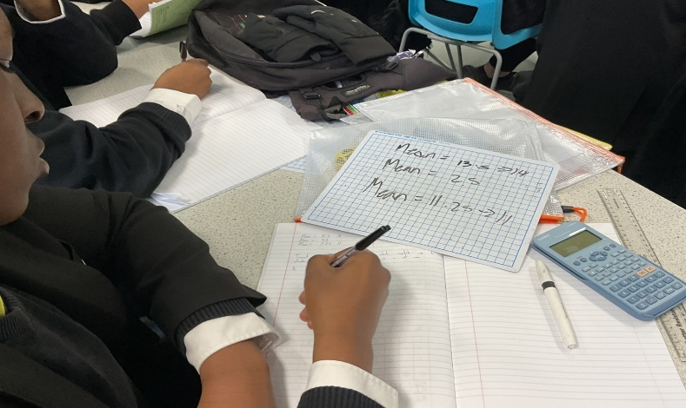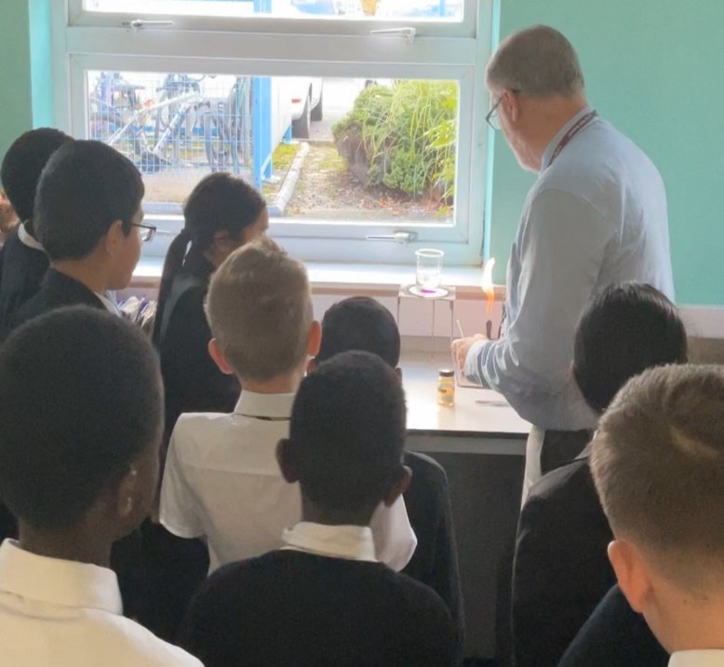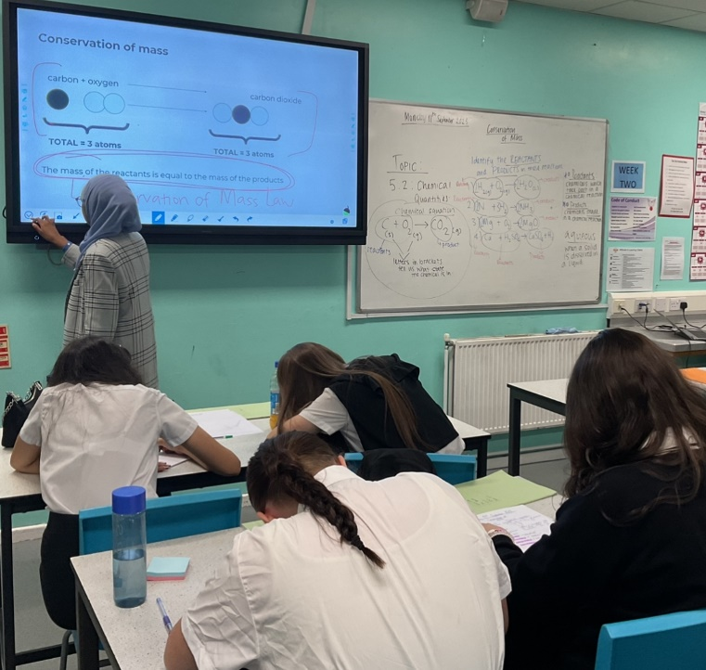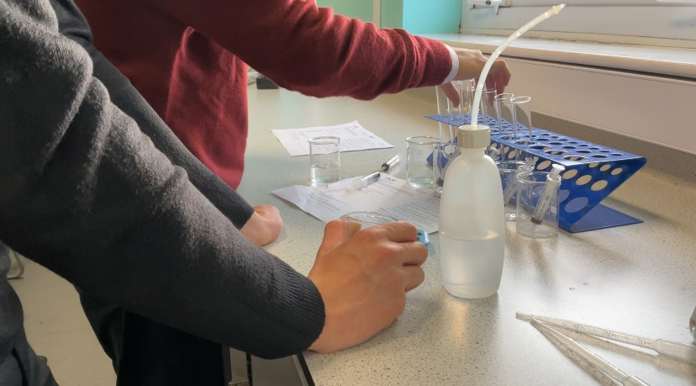

**Science**

**Developing strategic minds, explorative hands and inquisitive hearts.**

|  |  |
| --- | --- |
| **What is the vision for Science?**  Scientists of Lyng Hall break down the ‘why?’ behind what we see, hear and explore in the world around them. Science helps us to answer our biggest questions and to meet our most basic needs    We want to support students in doing this by providing them with opportunities to make connections, experiment, research and test both old and new theories.  The 3 main goals are:   1. Use and interpret science to explain the world around them 2. Evaluate and understand scientific theories and evidence 3. Investigate and generate scientific explanations   **Why do students at Lyng Hall need to study Science?**  Studying Science at Lyng Hall allows students to gain enthusiasm for the process of scientific discovery and understand how the world around us works.  Students get the opportunity to build connections between the world they see and how it works. Science provides a large range of transferable skills such as communication, practical skills, data analysis and scientific literacy skills. To achieve this, we consider the depth and breadth of theoretical and experimental science.  **What are the aims for your curriculum?**   1. Pupils will make good progress and achieve target grades, analysed through progress check data reviews. 2. Departmental tracking of students to identify underperformance 3. Pupils will show a development of practical skills and deepen knowledge and understanding 4. Pupils have the opportunity to revisit units covered in previous lessons. 5. Practical hands-on work in Science lessons and Science clubs to inspire and engage students in the love of Science 6. Promotion of Science through visits and STEM activities | |
|  | **Science Curriculum Overview/Long Term Plan Outline of taught and assessed content**  *The table below outlines the whole curriculum overview for this subject area, and shows the journey that students take throughout*  *Lyng Hall.* | |

**Key Stage 3**

|  |  |  |  |  |
| --- | --- | --- | --- | --- |
| **Week** | **Date** | **KS3 Science Curriculum overview** | | |
| **Year 7 KS3 Science** | **Year 8 KS3 Science** | **Year 9 KS3 Science** |
| 1 | 02/09/2024 | Induction Tasks and Working Scientifically | Breathing | Digestion |
| 2 | 09/09/2024 |
| 3 | 16/09/2024 | Cells |
| 4 | 23/09/2024 | Acids and Alkalis | Periodic Table **and** Elements |
| 5 | 30/09/2024 |
| 6 | 07/10/2024 | Speed |
| 7 | 14/10/2024 | Contact Forces **and** Gravity | Voltage and Resistance |
| 8 | 21/10/2024 |
| Half Term | | | | |
| 9 | 04/11/2024 | Particle Model | Contact Forces **and** Gravity | Voltage and Resistance |
| 10 | 11/11/2024 | Evolution |
| 11 | 18/11/2024 | Variation |
| 12 | 25/11/2024 | Human Reproduction |
| 13 | 02/12/2024 | Earth's Resources |
| 14 | 09/12/2024 | Earth Structure |
| 15 | 16/12/2024 | Metals and Non-Metals |
| Christmas | | | | |
|  |
| 16 | 06/01/2024 | Metals and Non-Metals | Circuits and Current | Work, Heating and Cooling |  |
| 17 | 13/01/2024 |  |
| 18 | 20/01/2024 | Sound |  |
| 19 | 27/01/2024 | Plant Reproduction | Respiration |  |
| 20 | 03/02/2024 |  |
| 21 | 10/02/2024 | Movement |  |
| Half Term | | | | |  |
| 22 | 24/02/2024 | Movement | Chemical Energy | Types of Reaction |  |
| 23 | 03/03/2024 |  |
| 24 | 11/03/2024 | Energy Costs and Energy Transfers | Pressure |  |
| 25 | 19/03/2024 | Magnets and Electromagnets |  |
| 26 | 27/03/2024 |  |
| 27 | 04/04/2024 | Seperating Mixtures | Photosynthesis | Inheritance |  |
| 28 | 12/04/2024 |  |
| Easter | | | | |  |
|  |
| 29 | 28/04/2024 | Seperating Mixtures | Photosynthesis | Inheritance |  |
| 30 | 05/05/2024 | Universe | Climate | Wave Effects and Wave Properties |  |
| 31 | 12/05/2024 |  |
| 32 | 19/05/2024 |  |
| Half Term | | | | |  |
| 33 | 02/06/2024 | Interdependence | Light | Preparation for GCSE Sciences |  |
| 34 | 09/06/2024 |  |
| 35 | 16/06/2024 |  |
| 36 | 23/06/2024 | Summer Activities / Crest Awards / Projects | Summer Activities / CREST Award / Project work |  |
| 37 | 30/06/2024 |  |
| 38 | 07/07/2024 |  |
| 39 | 14/07/2024 |  |

**Key Stage 4**

**Year 10**

|  |
| --- |
|  |
| |  |  |  |  |  |  |  | | --- | --- | --- | --- | --- | --- | --- | | **Week** | **Date** | **AQA GCSE Combined Science : Synergy** |  | **AQA GCSE Triple Science** | | | |  | **GCSE Biology** | **GCSE Chemistry** | **GCSE Physics** | | 1 | 02/09/2024 | Unit 1 Building Blocks : States of Matter |  | Unit 1 Cell Biology | Unit 1 Atomic Structure and the Periodic Table | Unit 1 Energy | | 2 | 09/09/2024 |  | | 3 | 16/09/2024 | Unit 1 Building Blocks : Atomic Structure |  | | 4 | 23/09/2024 |  | | 5 | 30/09/2024 | Unit 1 Building Blocks : Cells in Animals and Plants |  | | 6 | 07/10/2024 |  | | 7 | 14/10/2024 | Unit 1 Building Blocks : Waves |  | | 8 | 21/10/2024 |  | | Half Term | | | | | | | | 9 | 04/11/2024 | Unit 2 Transport over Larger Distances : Systems in the Human Body |  | Unit 2 Organisation | Unit 2 : Structure and Bonding | Unit 2 Electricity | | 10 | 11/11/2024 |  | | 11 | 18/11/2024 |  | | 12 | 25/11/2024 | Unit 2 Transport over larger distances : Plants and Photosynthesis |  | | 13 | 02/12/2024 |  | | 14 | 09/12/2024 | Unit 3 Interactions with the environment : Lifestyle and Health |  | | 15 | 16/12/2024 |  | | Christmas | | | | | | | |  | | 16 | 06/01/2024 | Unit 3 Interactions with the environment : Radiation and Risk |  | Unit 3 Infection and Response | Unit 3 Quantitative Chemistry | Unit 3 Particle model of matter |  | | 17 | 13/01/2024 |  |  | | 18 | 20/01/2024 | Unit 3 : Preventing, treating and curing disease |  |  | | 19 | 27/01/2024 |  |  | | 20 | 03/02/2024 | Unit 4 Explaining Change : The Earth's atmosphere |  |  | | 21 | 10/02/2024 |  |  | | Half Term | | | | | | |  | | 22 | 24/02/2024 | Unit 4 Explaining Change : Ecosystems and Biodiversity |  | Unit 3 Infection and Response | Unit 4 Chemical Changes | Unit 4 Atomic Structure |  | | 23 | 03/03/2024 |  |  | | 24 | 11/03/2024 | Unit 4 Explaining Change : Inheritance, Variation and Evolution |  | Unit 4 Bioenergetics |  | | 25 | 19/03/2024 |  |  | | 26 | 27/03/2024 |  | Unit 5 Forces |  | | 27 | 04/04/2024 | Unit 5 Building blocks for understanding : The Periodic Table |  |  | | 28 | 12/04/2024 |  |  | | Easter | | | | | | |  | |  | | 29 | 28/04/2024 | Unit 5 Building blocks for understanding : Chemical Quantities |  | Unit 7 Ecology | Unit 5 Energy Changes | Unit 5 Forces |  | | 30 | 05/05/2024 |  |  | | 31 | 12/05/2024 | Unit 6 Interactions over small and large distances : Forces and Energy |  |  | | 32 | 19/05/2024 |  | Unit 6 The rate and extent of Chemical Changes |  | | Half Term | | | | | | |  | | 33 | 02/06/2024 | Unit 6 Interactions over small and large distances : Structure and Bonding |  | Unit 7 Ecology | Unit 6 The rate and extent of Chemical Changes | Unit 5 Forces |  | | 34 | 09/06/2024 |  |  | | 35 | 16/06/2024 | 6.3 Magnetism and Electromagnetism |  |  | | 36 | 23/06/2024 | Mocks and Work Experience | | | | |  | | 37 | 30/06/2024 |  | | 38 | 07/07/2024 |  | | 39 | 14/07/2024 |  | |

**Year 11**

|  |  |  |  |  |  |  |
| --- | --- | --- | --- | --- | --- | --- |
| **Week** | **Date** | **AQA GCSE Combined Science : Synergy** |  | **Triple Science** | | |
|  | **Biology** | **Chemistry** | **Physics** |
| 1 | 02/09/2024 | Unit 7 Movement and Interactions : Forces and Motion |  | Unit 5 Homeostasis and Response | Unit 7 Organic Chemistry | Unit 6 Waves |
| 2 | 09/09/2024 |  |
| 3 | 16/09/2024 |  |
| 4 | 23/09/2024 | Unit 7 Movement and Interactions : Electricity |  |
| 5 | 30/09/2024 |  |
| 6 | 07/10/2024 |  | Unit 7 Magnetism and Electromagnetism |
| 7 | 14/10/2024 | Unit 7 Movement and Interactions : The rate and extent of chemical change |  |
| 8 | 21/10/2024 |  |
| Half Term | | Half Term | | | | |
| 9 | 04/11/2024 | REVISION Paper 1 and 2 |  | REVISION Paper 1 | | |
| 10 | 11/11/2024 |  |
| 11 | 18/11/2024 | Mock Exams | | | | |
| 12 | 25/11/2024 |
| 13 | 02/12/2024 | Unit 7 Movement and Interactions : Acids and Alkalis |  | Unit 6 Inheritance Variation and Evolution | Unit 8 Chemical Analysis | Unit 7 Magnetism and Electromagnetism |
| 14 | 09/12/2024 |  |
| 15 | 16/12/2024 |  |
| Christmas | | Christmas | | | | |
|  |
| 16 | 06/01/2024 | Unit 7 Movement and Interactions : Atoms into ions and ions into atoms |  | Unit 6 Inheritance Variation and Evolution | Unit 9 Chemistry of the Atmosphere | Unit 8 Space Physics |  |
| 17 | 13/01/2024 |  |  |
| 18 | 20/01/2024 | Unit 8 Guiding spaceship earth : Carbon Chemistry |  |  |
| 19 | 27/01/2024 |  | Unit 10 Using Resources |  |
| 20 | 03/02/2024 | Unit 8 Guiding spaceship earth : Resources of materials and Energy |  |  |
| 21 | 10/02/2024 |  |  |
|  | | Half Term | | | | |  |
| 22 | 24/02/2024 | REVISION Paper 3 and 4 |  | REVISION Paper 2 | | |  |
| 23 | 03/03/2024 |  |  |
| 24 | 11/03/2024 | Mock Exams | | | | |  |
| 25 | 19/03/2024 |  |
| 26 | 27/03/2024 | REVISION | | | | |  |
| 27 | 04/04/2024 |  |
| 28 | 12/04/2024 |  |
| Easter | | Easter | | | | |  |
|  |
| 29 | 28/04/2024 | REVISION | | | | |  |
| 30 | 05/05/2024 |  |
| 31 | 12/05/2024 |  |
| 32 | 19/05/2024 |  |
| Half Term | | Half Term | | | | |  |
| 33 | 02/06/2024 | REVISION and EXAM SUPPORT | | | | |  |
| 34 | 09/06/2024 |  |
| 35 | 16/06/2024 |  |
| 36 | 23/06/2024 |  |

**Key Stage 5 – OCR A Level Biology**

Year 12

**Term 1**

* Biological Molecules (Water, Carbohydrates, Lipids, Proteins and Enzymes)
* Nucleotides and Nucleic Acids
* Cell Structure, Microscopy and Membranes
* Cell Division, Diversity and Organisation

**Term 2**

* Exchange surfaces, Mammalian Ventilation, Insect and bony fish ventilation
* Transport in animals
* The Cardiac cycle and Circulatory System in Mammals
* Communicable disease and Immunity
* Biodiversity and Sampling Techniques

**Term 3**

* Transport in plants
* Plant adaptations to water availability
* Biodiversity
* Classification, Evolution and Natural Selection

Year 13 Biology

**Term 1**

* Photosynthesis and Respiration
* Homeostatic control of temperature and excretion
* Neuronal Communication
* Hormonal Communication
* Plant and Animal Responses

**Term 2**

* Cellular control of gene expression
* Patterns of Inheritance
* Manipulating genomes
* Ecosystems

**Term 3**

* Cloning and Biotechnology
* Populations and Sustainability

**Key Stage 5 – OCR A Level Chemistry**

Year 12

**Term 1**

* Atomic Structure and Isotopes
* Compounds and Equations
* Moles
* Determination of Formula
* Yield and Atom Economy
* Acids and Bases
* Titrations
* Redox
* Bonding and Structure

**Term 2**

* Periodicity and Groups
* Enthalpy Changes
* Kinetics and Equilibria

**Term 3**

* Organic Chemistry
* Alkanes and Alkenes
* Alcohols and Haloalkanes
* Organic Synthesis
* Analytical Techniques

|  |
| --- |
| **Curriculum Breakdown** |
| **Why is it taught in the order that it is?**  **Key stage 3**  The curriculum narrative builds upon the work carried out at KS2 and follows the national curriculum. The paragraphs below give a summary of journey through the curriculum for each year group within KS3 and suggests how understanding by the end of that year sets pupils up well for the next.    **Year 7**   * Students are taught approximately 3 topics per half term as this allows them to slowly build knowledge of all 3 sciences. We start with core knowledge including cells, atoms and energy. From this we can build students' knowledge and confidence in Science. * We build on KS2 knowledge, focussing on developing scientific language and practical skills. * Without building a solid core knowledge students will struggle to make progress in future years.   **Year 8**   * Students continue to be taught approximately 3 topics per half term as this allows them to slowly build knowledge of all 3 sciences. We build on knowledge from year 7 developing both scientific knowledge and practical skills. * Interleaving topics gives students the opportunity to recap and consolidate knowledge from both year 8 and 7 topics   **Year 9**   * Students continue to be taught approximately 3 topics per half term as this allows them to slowly build knowledge of all 3 sciences. We build on knowledge from year 7 and 8 developing both scientific knowledge and practical skills. * Interleaving topics gives students the opportunity to recap and consolidate knowledge from both year 7, 8 and 9 topics * In the final term, students planning to opt for Triple Science will be offered a curriculum designed to prepare them for the additional content and depth of Triple Science at GCSE   **Key stage 4**  The curriculum narrative builds upon the work carried out in Key Stage 3 and follows the subject# specification. Most students will study the AQA Synergy Science pathway. Our rationale for this is to ensure that we teach Science in a way that promotes, highlights and encourages the many cross disciplinary links between Science topics. We feel that teaching a double science qualification this way avoids the teaching of three Separate Sciences as distinct entities. For example, students can learn about atomic structure with its links to both Chemistry and Physics rather than as a piecemeal approach over 2 years. Chemical reactions and Kinetic theory can be taught alongside biological reactions to highlight the links. |

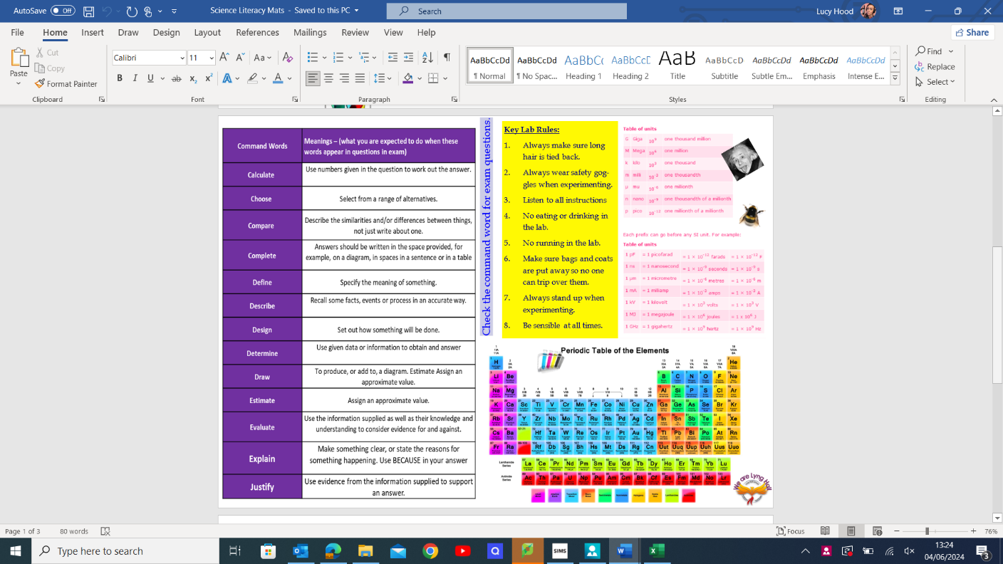**Literacy in Science**

The Science Department have worked extremely hard to create and provide learning environments that support and develop key literacy skills. With live word walls, literacy mats and tiered language in every classroom, students are updated and supported each lesson to build their vocabulary and understanding with scientific language and terminology in the world around them. In class books there are vocab checklists, knowledge organisers, wordsearch activities, gap fill and many more to support students all the way through to their final exams and answering higher mark questions. Teachers use additional texts and key language as part of their teaching practice to support learners to develop their oracy, reading and writing skills.

